**Facebook Sharing**

**Facebook App:**

Create Facebook App to use Facebook Graph endpoints like: post or feeds.

**Steps:**

1. Create Facebook Application here: [https://developers.facebook.com/apps/](%20https:/developers.facebook.com/apps/) with following properties:

E.g.:

Display name => SocialSharing

App Contact Email => youremail@domain.com

App Purpose => Yourself or your own business

1. Change App Settings here: <https://developers.facebook.com/apps/417311286619563/settings/basic/>

E.g.:

App Domains => yourdomain.com or localhost

Privacy Policy URL => http://gmail.com/

App Icon => Image (1024 x 1024)

Require App Secret => Yes (!!! If Yes, should send “appsecret_proof” as parameter for permanent fix: <https://developers.facebook.com/docs/graph-api/security>)

**Scope/Permissions:**

Scope and permissions are required to perform the actions provided by Facebook graph API like: manage pages, post or get list of user posts. Request scope by going to this link:

<https://developers.facebook.com/apps/616310719747068/app-review/permissions/>

**Scope:**

pages_manage_posts, publish_to_groups,pages_read_engagement,pages_read_user_content

**Business Manager:**

Facebook business manager allows you to manage multiple Facebook Pages, business assets and ad accounts.

**Steps:**

1. Create Facebook Business Manager account with the business email used to create the Facebook account and page from link: <https://business.facebook.com/>

**Domain Verification:**

Domains of links used for pictures and documents should be verified before used in the posts using Facebook Business Manager.

**Steps:**

1. Go to Business Settings > Brand Safety > Domains menu in Business Manager site and add the domain using “Add” button:
2. After clicking add domain name from which link and picture links are to be shared as shown in screenshot below and save.

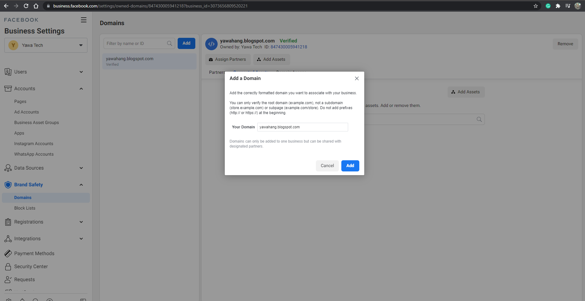

**Add Pages:**

Add pages to accounts and domains in order to provide access to modify or view the contents of pages.

**Steps:**

1. Add Pages

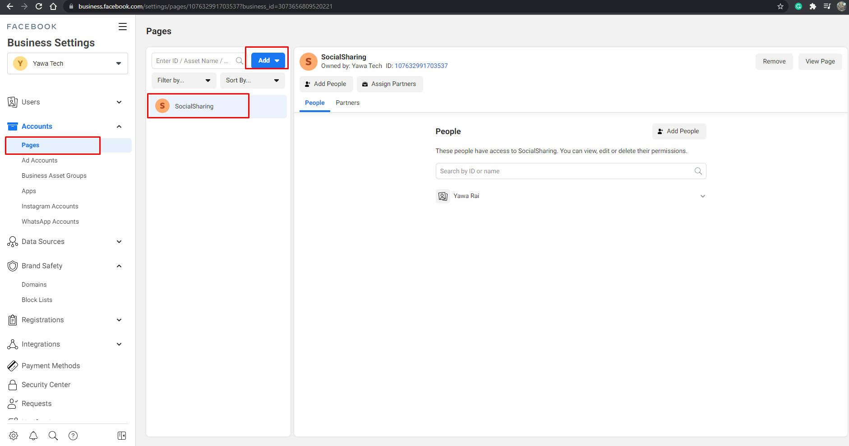

1. Assign Page to Domain.

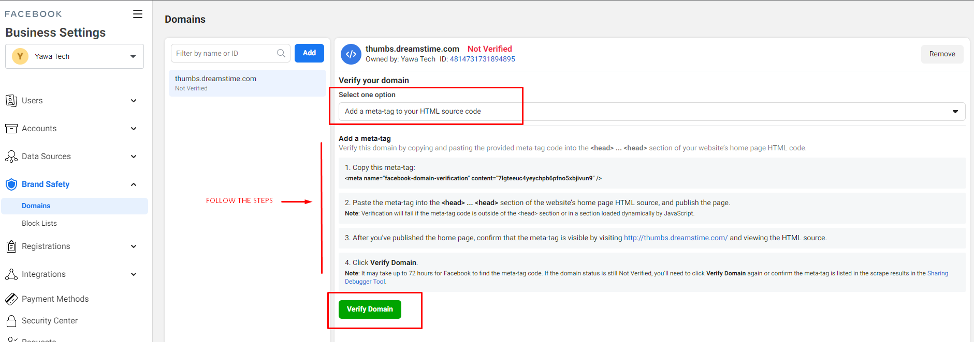

**References:**

Examples:

<http://facebooksdk.net/docs/making-synchronous-requests>

<https://www.youtube.com/watch?v=IsO0G-8idyo>

Individual Verification Paused:

<https://developers.facebook.com/blog/post/2020/03/24/pausing-individual-verification/>

Individual Verification:

<https://developers.facebook.com/docs/development/release/individual-verification/>